Spring​ ​​Qi​ ​Gong​ ​Workshop

*​Saturday​ ​13th​ ​April,​ ​10am-4pm*

Immerse​ ​yourself​ ​in​ ​day​ ​of​ ​​Qi​ ​Gong​ & Dao Yin exercises ​to​ ​experience​ ​a​ ​deepening​ ​and refining​ ​of​ ​your​ ​practice.​ ​The Rococo Gardens​ ​provide​ a​n inspiring ​setting​, a unique 18th century garden within a hidden valley.

It​ ​is​ ​recommended​ ​you​ ​visit​ ​www.rococogarden.org.uk
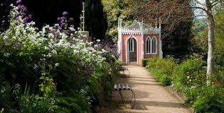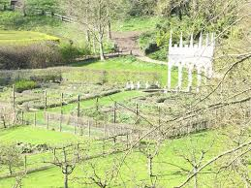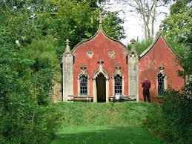

Here is a ​chance​ ​to​ ​explore​ ​a​ ​variety​ ​of​ ​Dao Yin exercises and Qi​ ​Gong​ ​forms​ with ​Meditation​ ​exercises.​ ​There​ ​are opportunities​ ​to​ ​practice​ within ​the​ ​Garden and indoors. The Cafe offers a wide range of refreshments.

Teachings​ ​will​ ​be​ ​offered​ ​by​ ​Jeff​ ​Docherty​ ​and​ ​Mark​ ​Collins,​ ​both​ ​having​ ​20+ years​ ​of​ ​experience.

Bookings:
- The​ ​Workshop​ ​will cost​ ​£55.
- Numbers will be restricted to 12 practitioners.
- Reservations​ ​require​ ​a​ ​non-refundable​ ​deposit​ ​of​ ​£30,​ ​with​ ​full payment​ ​by​ ​1st​ ​March.

Mark:​ ​07981805206 cotswoldtaichi@talktalk.net

Jeff:​ ​07970303694 jeffdocherty@yahoo.com

