Taiji-Qi Gong & Bodywork Retreat

* Friday 19th to Sunday 21st August 2022 *

Immerse yourself in a weekend of Taiji & Qi Gong and Body work to experience a deepening and refining of your practice. Braziers provides the perfect environment, a tranquil Gothic Mansion set in 55 acres of meadows and woodland. It is a thriving secular Community and Educational Trust.

It is highly recommended you visit www.braziers.org.uk to discover more.

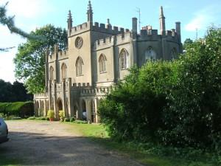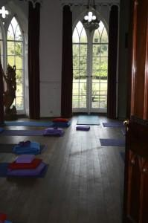

" The Retreat has done me the world of good"…………….."I felt really brilliant after;

"I hugely enjoyed the Qigong/Tai Chi weekend at Braziers Park, an architectural gem…."

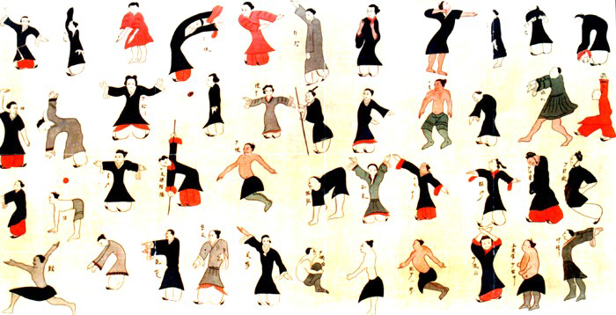

Throughout the weekend there will be the chance to explore either Chen or Sun styles of Taiji, a wide variety of Qi Gong forms along with Bodywork-Shiatsu sessions and Meditation exercises. There are opportunities to practice on sunny terraces, in screened gardens, orchards and woodland.

Teachings are offered by Jeff Docherty & Mark Collins, practitioners of 20+ years.

Bookings: (www.cotswoldedgetaichi.co.uk)
- Reservations require a non-refundable deposit of £100.
- Fully incl. costs for two nights, full board & tuition from Fri 4pm - Sunday 4pm

- The Retreat with a Single Room is £365
- For a Shared Room with one other £315
- There is an eco-camping option at £285
Mark: 07981805206 cotswoldtaichi@gmail.com
Jeff: 07970 303694 jeffdocherty@yahoo.com

